 | United States Department of the Interior  FISH AND WILDLIFE SERVICE  911 NE 11th Avenue  Portland, Oregon 97232-4181 |  | 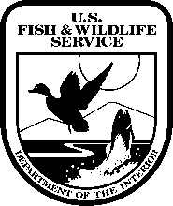
In Reply Refer to:
FWS/R1/NWRS-RR

Memorandum

To: Chief, Branch of Conservation Planning
Attn: Ross Alliston

From: Acting Chief, Branch of Conservation Planning

Subject: Freedom of Information Act Request from John Greenewald regarding the Refuge Planning Toolbox

In response to the subject request we received from the Headquarters’ Freedom of Information Act Office (see attached email), the CD-ROMs we sent for the prior FOIA request for the Refuge Planning Toolbox (Michael Ravnitsky) are also responsive to this request. The CDs contain the files we posted on the Region 1 internal website, the Refuge Planning Toolbox, for our field-based planners to reference. Please note, the toolbox has not been updated or active since 2011, and some of the information is outdated.

Please contact Charlie Pelizza, Chief, Branch of Conservation Planning and Visitor Services, for further information, at phone number (503) 231-6176, or via email at charlie_pelizza@fws.gov.

